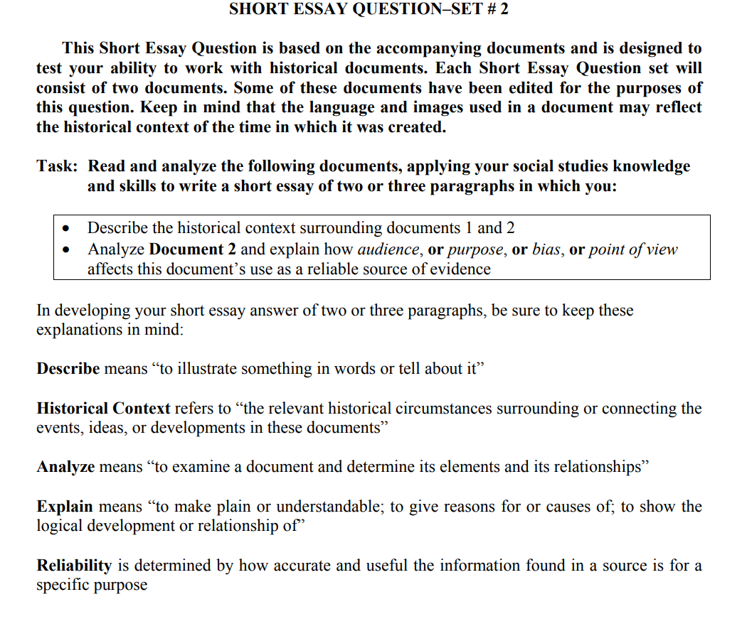

Document 1
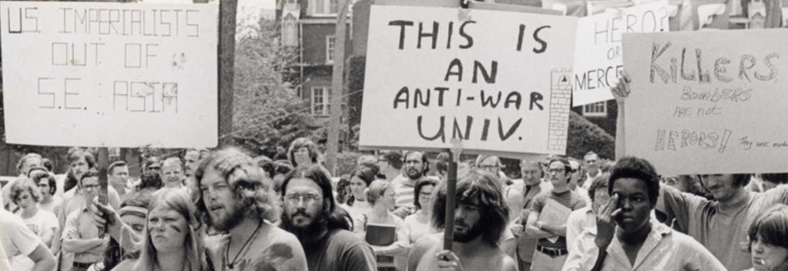
Photo courtesy of University of Florida Archives
https://web.uflib.ufl.edu/spec/exhibits/altufwar.htm

Document 2
